**RDBMS LAB - 02**

NAME- Ragini Sharma

ID-B120062

1. Inserting all records from another relation

Syntax: INSERT INTO relation_name_1 SELECT Field_1,field_2,field_n FROM relation_name_2

WHERE field_x=data;

Example: SQL>INSERT INTO student1 SELECT sno,sname FROM student2 WHERE name = ‘Ramu’;

Example 1:

**Code-**

CREATE TABLE student1(sno INT, sname VARCHAR(30));

CREATE TABLE student2(sno INT, sname VARCHAR(30));

INSERT INTO student2

VALUES(25, "Ramu"), (30, "Namita"), (7, "Ananya");

INSERT INTO student1 SELECT sno, sname FROM student2 WHERE sname="Ramu";

Output-

Example 2:

**Code-**

CREATE TABLE employee1(id INT, name VARCHAR(30), dept VARCHAR(50));

CREATE TABLE employee2(id INT, name VARCHAR(30), dept VARCHAR(50));

INSERT INTO employee2

VALUES(2345, "Arjun", "Legal"), (8725, "Sid", "Finance"), (3321, "Rohan", "HR");

INSERT INTO employee1 SELECT id, name, dept FROM employee2 WHERE dept="HR";

**Output-**

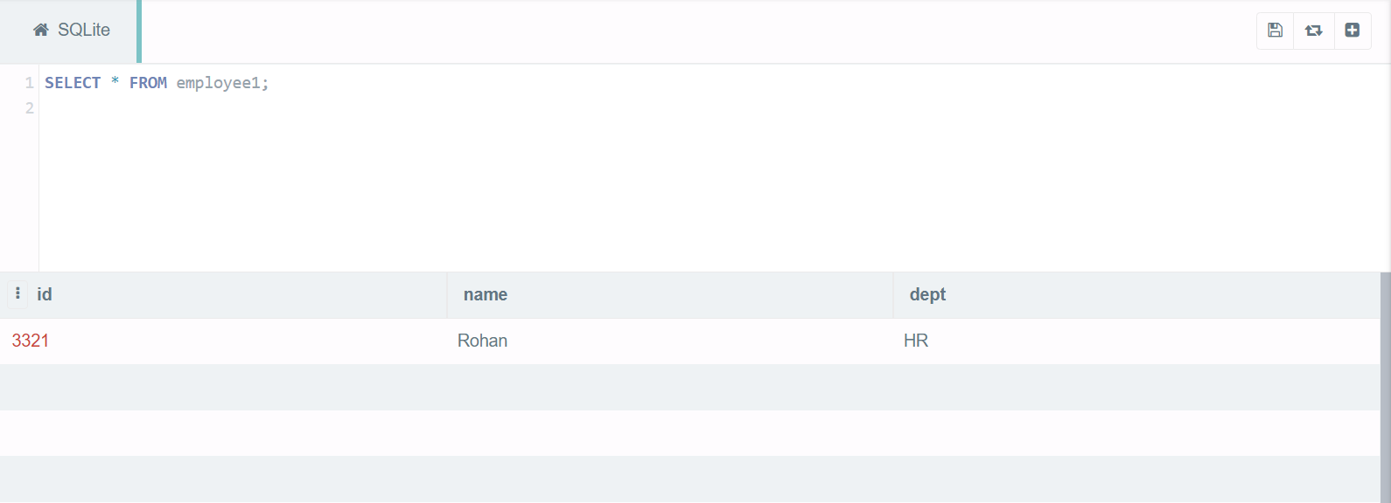

1. UPDATE-SET-WHERE: This is used to update the content of a record in a relation.

Syntax: SQL>UPDATE relation name SET Field_name1=data,field_name2=data, WHERE

field_name=data;

Example: UPDATE Persons SET Name = 'kumar' WHERE ID='value';

Example 1:

**Code-**

CREATE TABLE Persons(id INT, name VARCHAR(30));

INSERT INTO Persons

VALUES(12, "Abhishek"), (34, "Pratham"), (55, "Ritwik");

UPDATE Persons SET name="Raj" WHERE id=55;

**Output-**

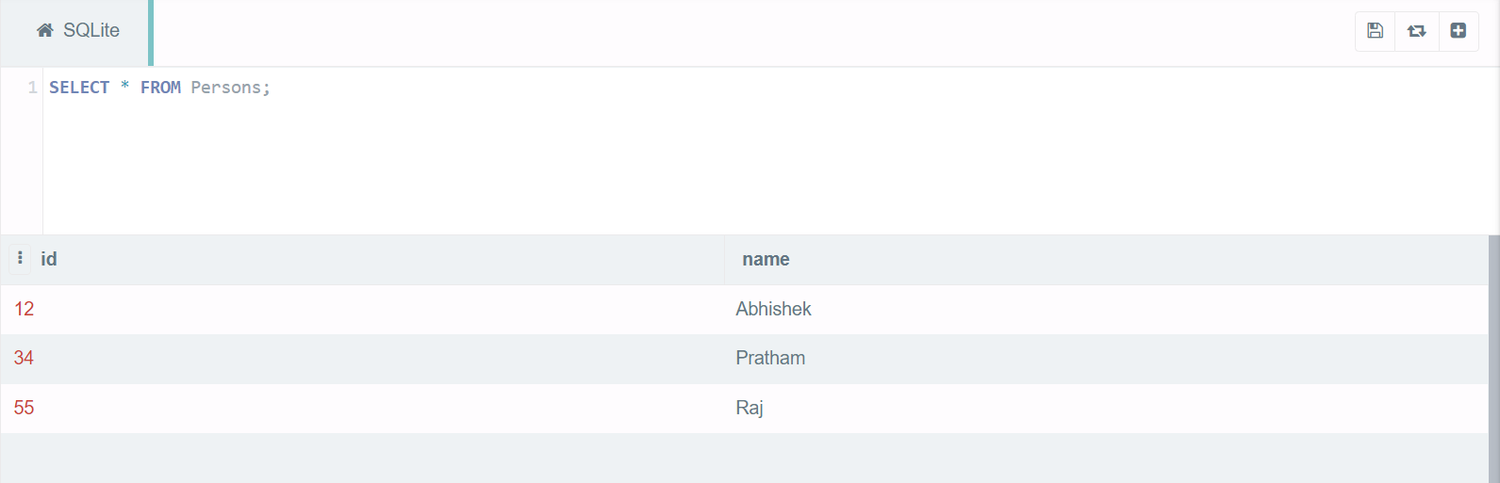

Example 2:

**Code-**

CREATE TABLE Equipments(id INT, name VARCHAR(30), sport VARCHAR(30));

INSERT INTO Equipments

VALUES(234, "Bat", "Cricket"), (12, "Ping-Pong Ball", "Table-Tennis"), (569, “Racquet”, “Badminton”);

UPDATE Equipments SET name="Shuttle Cock" WHERE sport="Badminton";

**Output-**

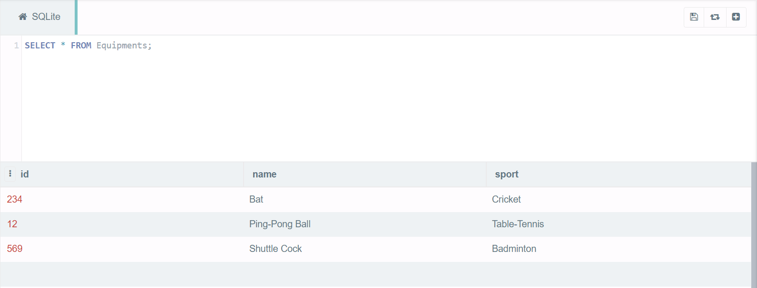

1. DELETE-FROM: This is used to delete all the records of a relation but it will retain the structure of

that relation.

Syntax: SQL>DELETE FROM relation_name;

Example: SQL>DELETE FROM student;

Example 1:

**Code-**

CREATE TABLE student(id INT, name VARCHAR(30), class INT, percentage REAL);

INSERT into student

VALUES(10, "Ajay", 10, 89.56), (22, "Joseph", 12, 76.79), (78, "Yash", 11, 97.32), (66, "Rajesh", 12, 90.18);

DELETE FROM student;

**Output-**

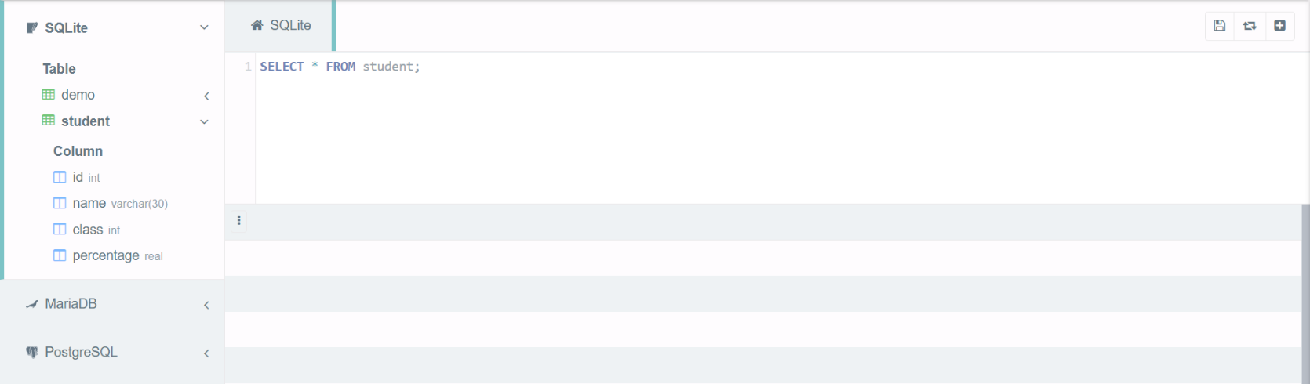

Example 2:

**Code-**

CREATE TABLE subjects(classes INT, name VARCHAR(20));

INSERT into subjects

VALUES(4, "DAA"), (4, "COA"), (5, "BME"), (3, "ED"), (4, "DM"), (1, "CS");

DELETE FROM subjects;

**Output-**

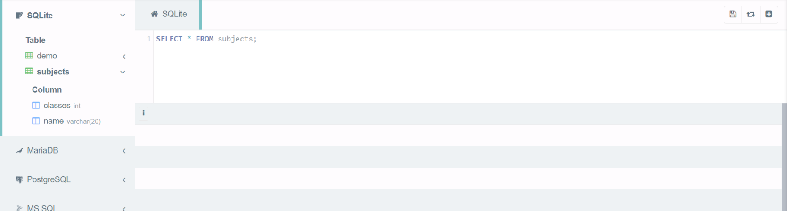

1. SELECT FROM: To display all fields for all records.

Syntax : SELECT * FROM relation_name;

Example : SQL> select * from dept;

Example 1:

**Code-**

CREATE TABLE dept(sno INT, name VARCHAR(20));

INSERT INTO dept

VALUES(1, "Computer Science"), (2, "Electrical"), (3, "Mechanical"), (4, "Civil");

SELECT * FROM dept;

**Output-**

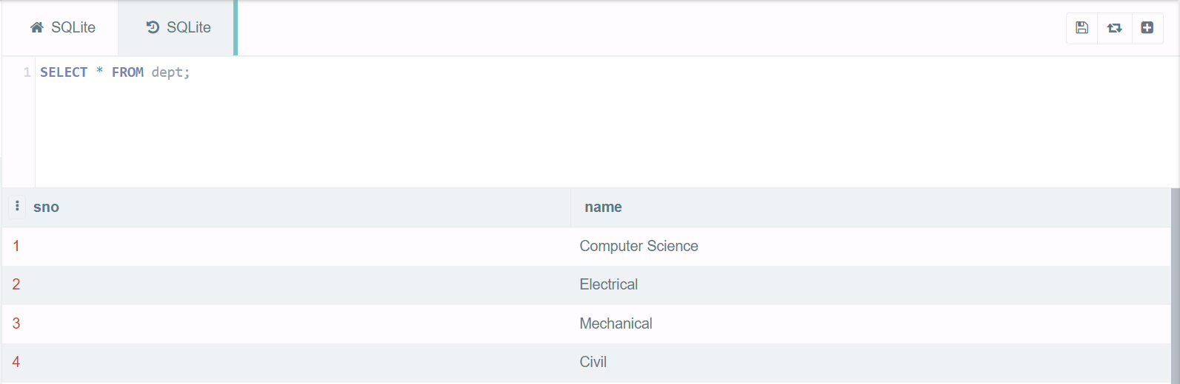

Example 2:

**Code-**

CREATE TABLE stationary(id INT, name VARCHAR(20), price INT);

INSERT INTO stationary

VALUES(2356, "Pencil", 20), (4459, "Pen", 50), (1190, "Notebook", 200);

SELECT * FROM stationary;

**Output-**

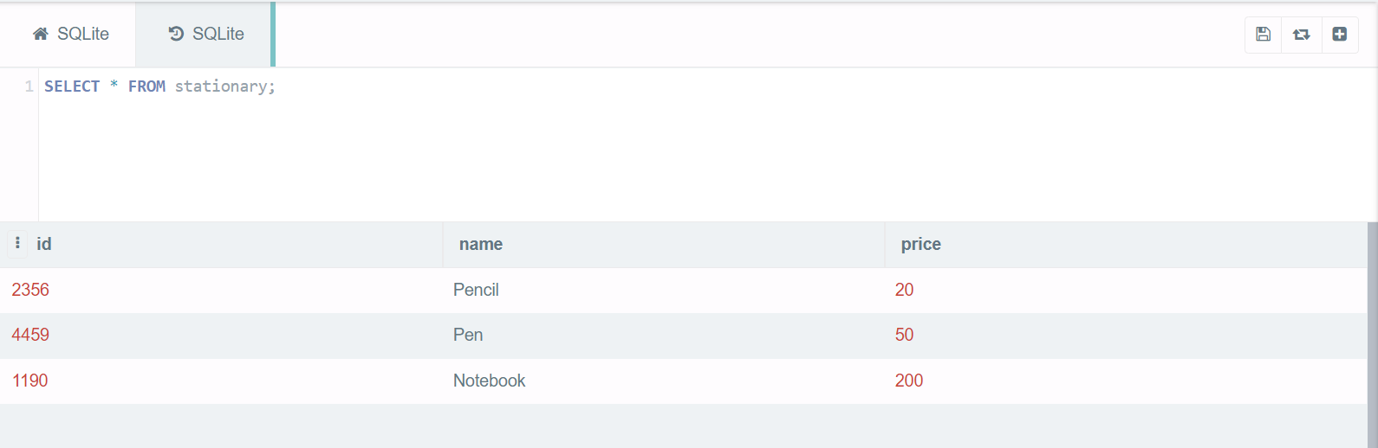

1. SELECT FROM: To display a set of fields for all records of relation.

Syntax: SELECT a set of fields FROM relation_name;

Example: SQL> select deptno, dname from dept;

Example 1:

**Code-**

CREATE TABLE dept(deptno INT, dname VARCHAR(20), head VARCHAR(30));

INSERT into dept

VALUES(124, "Computer Science", "Prof. Rajesh Khanna"), (346, "Electrical", "Prof. Krishna Kumar"), (254, "Mechanical", "Prof. Gopal Rao");

SELECT dname, head FROM dept;

**Output-**

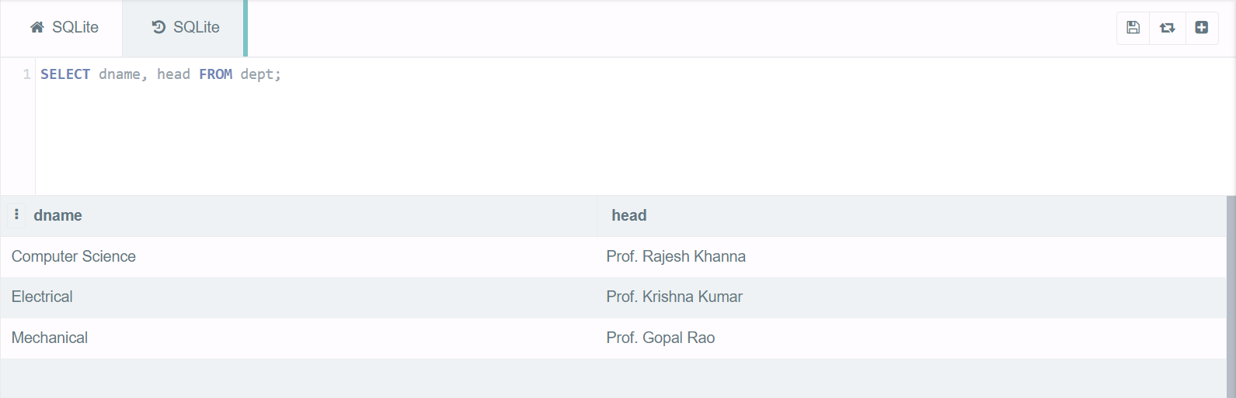

Example 2:

**Code-**

CREATE TABLE cars(quantity INT, brand VARCHAR(20), price INT);

INSERT INTO cars

VALUES(20000, "BMW", 10000000), (25000, "Audi", 14000000), (5000, "Porche", 40000000);

SELECT quantity, brand FROM cars;

**Output-**

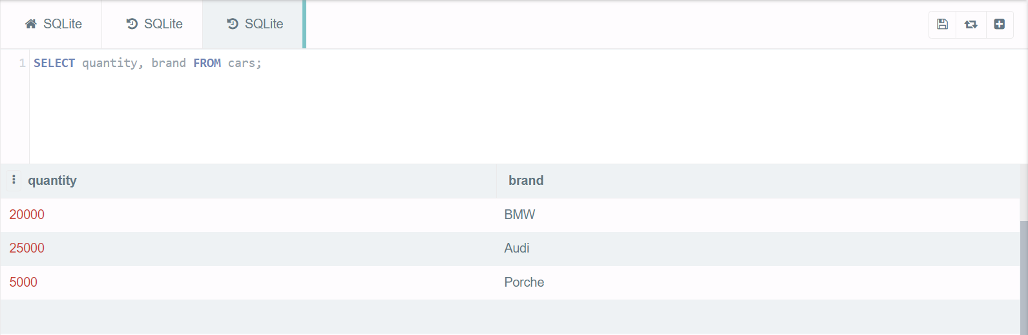

1. SELECT - FROM -WHERE: This query is used to display a selected set of fields for a selected set of

records of a relation.

Syntax: SELECT a set of fields FROM relation_name WHERE condition;

Example: SQL> select * FROM dept WHERE deptno<=20;

Example 1:

**Code-**

CREATE TABLE dept(deptno INT, deptname VARCHAR(20), city VARCHAR(20));

INSERT into dept

VALUES(675, "Computer Science", "Mumbai"), (100, "Electrical", "Bangalore"), (999, "Mechanical", "Delhi");

SELECT * FROM dept WHERE deptno<800;

**Output-**

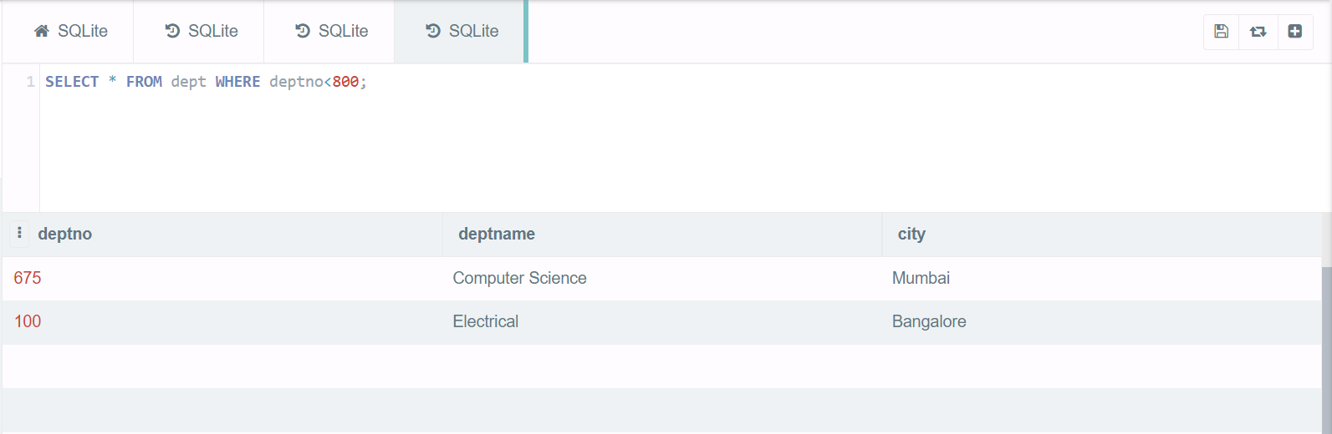

Example 2:

**Code-**

CREATE TABLE ecommerce(name VARCHAR(30), rating INT, users INT);

INSERT into ecommerce

VALUES("Amazon", 9, 2000), ("Flipkart", 7, 3000), ("Snapdeal", 8, 1000), ("EBay", 6, 2500);

SELECT name, rating FROM ecommerce WHERE users<2500;

**Output-**

